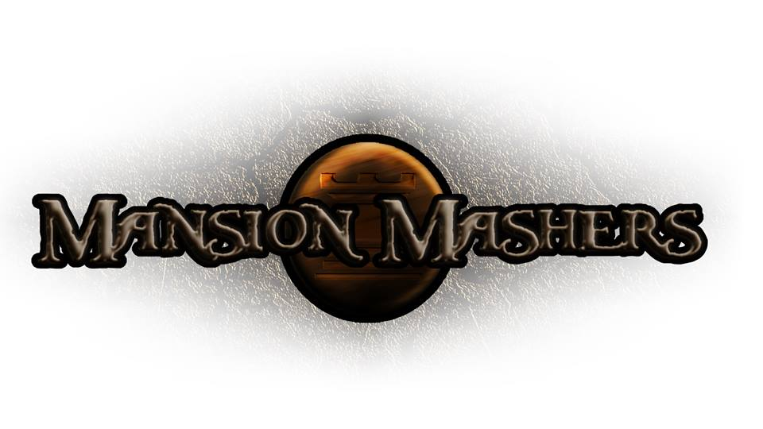**Weekly Production Report**

**Week 11**

**March 27, 2014**

**By Juli Gregg**

**High Concept**:

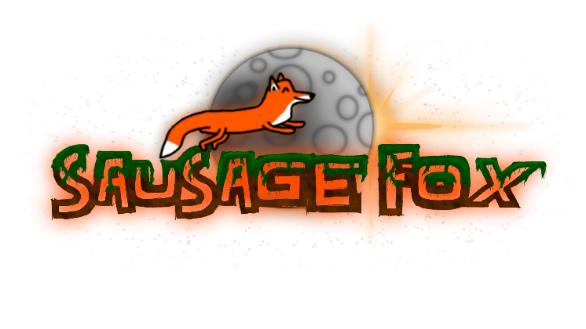A 2-D fast-paced, side scrolling hack and slash game set in a cartoon fantasy world with character ability progression.

**Producer:**

Juli Gregg

**Tech Director**:

Dan Muller

**Game Designer**:

Luke Conlon

**Product Manager**:

Kaden Nugent

Project Status:

Green

Current Milestone:

Beta

Accomplishments:

|  |  |
| --- | --- |
| **Juli Gregg:** | Finished background art for levels 3,4,6,7 and started backgrounds for boss levels and level 5. Finished setup of platforms, walls, spawners, boundaries, win conditions and camera for non-boss levels. |
| **Dan Muller:** | Added circle to rectangle collision, new text sheet, text disappear/reappear effects, weapon rarities, and restart button to pause menu. Finished up mechanics for three of four bosses. Bug fixes. |
| **Luke Conlon:** | Fixed player animation. Textured backgrounds and trees. Added parallax backgrounds. Working on boss animation for first boss. |
| **Kaden Nugent:** | Switched drawing scaling to be matrix based for aspect ratio. Added more projectiles. Finishing up Tutorial features. Glitch repairs and level touch ups. |

Objectives:

|  |  |
| --- | --- |
| **Juli Gregg:** | Finish up boss backgrounds. Create art for buffs and place in levels. Add in sounds and narrative voices/text. Create presentation assets. |
| **Dan Muller:** | Add an infinite spawner, block ability, and a counter/timer to HUD. Make enemies drop weapons and improve map usability. Create final boss. |
| **Luke Conlon:** | Work to finish boss art/animation and implement it in the game to work with boss AI. |
| **Kaden Nugent:** | Add experience system and level up system. Add the remaining three shops. General glitch repair and level touch ups. |

Group Accomplishments:

|  |  |
| --- | --- |
| **Weekly Group Meeting** | Recorded voice sound effects and narrative for the game with our sound designer. |
| **Repository**  **Commit Stats** | This week: 38 (not including spring break)  In a month: 211 |

Group Objectives:

|  |  |
| --- | --- |
| **Weekly Group Meeting** | Discuss what we want to present at Beta Presentations and what we need finished to have our game at the polishing stage. |

Highlights:

Dan is happy when new people play our game. Kaden was happy that he had a leisurely conversation with Mead. Luke is glad that Mark Ward wants us to be his COL101 TA’s. Juli was glad that almost all level art is done.

Risks & Mitigations:

|  |  |
| --- | --- |
| **RISKS:** | (1) We have a lot of plans for this game that due to limited amount of time we may not be able to implement everything that we want to.  (2) We have a lot of tests the week of beta.  (3) Sound assets still need to be placed in the game. |
| **MITIGATIONS:** | (1) Attempt to keep a realistic timeline and slowly weave in stretch goals as we achieve the basic requirements to make our game functional and fun.  (2) Designate time to study separate from time spent working on game.  (3) Our sound designer has promised to give us our assets this week to place in the game before beta. |

**Signatures**

_____________________

Juli Gregg

_____________________

Dan Muller

_____________________

Luke Conlon

_____________________

Kaden Nugent